**STATES-**

1. **MAHARASHTRA**

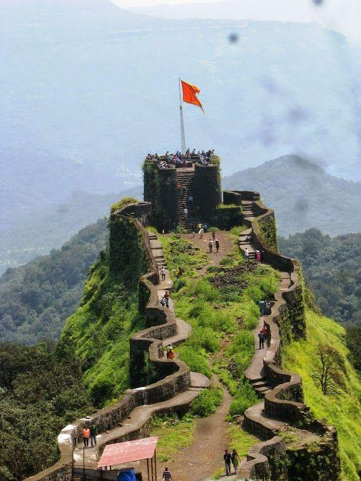

**Maharashtra** is a [state](https://en.wikipedia.org/wiki/States_and_union_territories_of_India) in the [western](https://en.wikipedia.org/wiki/Western_India) peninsular region of [India](https://en.wikipedia.org/wiki/India) occupying a substantial portion of the [Deccan Plateau](https://en.wikipedia.org/wiki/Deccan_Plateau). It is bordered by the [Arabian Sea](https://en.wikipedia.org/wiki/Arabian_Sea) to the west, the Indian states of [Karnataka](https://en.wikipedia.org/wiki/Karnataka) and [Goa](https://en.wikipedia.org/wiki/Goa) to the south, [Telangana](https://en.wikipedia.org/wiki/Telangana) to the southeast and [Chhattisgarh](https://en.wikipedia.org/wiki/Chhattisgarh) to the east, [Gujarat](https://en.wikipedia.org/wiki/Gujarat) and [Madhya Pradesh](https://en.wikipedia.org/wiki/Madhya_Pradesh) to the north, and the Indian [union territory](https://en.wikipedia.org/wiki/Indian_union_territories) of [Dadra and Nagar Haveli and Daman and Diu](https://en.wikipedia.org/wiki/Dadra_and_Nagar_Haveli_and_Daman_and_Diu) to the northwest.

* **FAMOUS PLACES-**

1. ***Ajanta Caves and Ellora Caves***-

**The Ajanta Caves** are 29 [rock-cut](https://en.wikipedia.org/wiki/Rock_cut_architecture) [Buddhist cave monuments](https://en.wikipedia.org/wiki/Buddhist_caves_in_India) dating from the second century [BCE](https://en.wikipedia.org/wiki/Common_Era) to about 480 CE in the [Aurangabad District](https://en.wikipedia.org/wiki/Aurangabad_District,_Maharashtra) of [Maharashtra](https://en.wikipedia.org/wiki/Maharashtra) state in [India](https://en.wikipedia.org/wiki/India). Ajanta Caves are a [UNESCO](https://en.wikipedia.org/wiki/UNESCO) [World Heritage Site](https://en.wikipedia.org/wiki/World_Heritage_Site). Universally regarded as masterpieces of [Buddhist religious art](https://en.wikipedia.org/wiki/Buddhist_art), the caves include paintings and rock-cut sculptures described as among the finest surviving examples of [ancient Indian art](https://en.wikipedia.org/wiki/Ancient_Indian_architecture), particularly expressive paintings that present emotions through gesture, pose and form.

**Ellora Caves** are a rock-cut Buddhist, Jain and Hindu cave complex, with artwork dating from the period 600–1000 CE, located in the [Aurangabad District](https://en.wikipedia.org/wiki/Aurangabad_district,_Maharashtra) of [Maharashtra](https://en.wikipedia.org/wiki/Maharashtra), [India](https://en.wikipedia.org/wiki/India). Ellora is a [UNESCO World Heritage Site](https://en.wikipedia.org/wiki/UNESCO_World_Heritage_Site).

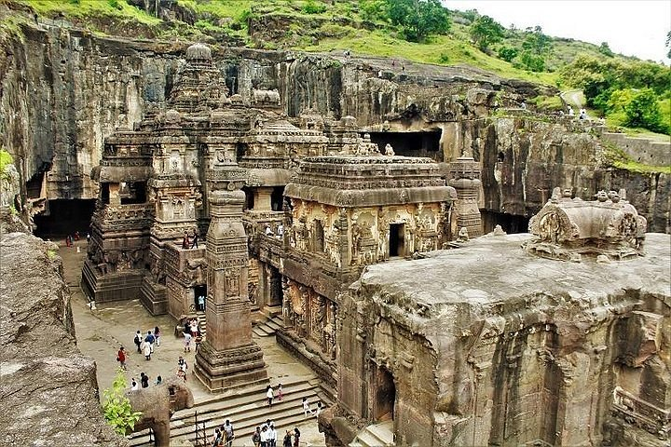

* **TRANSPORTATION-**

Flight-

Aurangabad, which is about 99 km from Ajanta and 30 km from Ellora, can be reached directly from Delhi, Mumbai, Jaipur and Udaipur airports. All types of cabs and buses are available from there.

Road-

Ajanta Caves are connected to a network of excellent roadways with Mumbai, Pune, Ahmednagar, Jalgaon, Shirdi, Nasik, Dhule, Ahmedabad, Hyderabad, Indore, Bijapur, and Aurangabad. Numerous bus services are running to Ellora from Aurangabad Central Bus Station, but the Maharashtra State Tourism Corporation (MTDC) Bus Service is most reliable.

Train-

Jalgaon and Aurangabad are the two railway junctions. These junctions are very well-connected via major trains from all across India. The train ride is very convenient, comfortable and pocket friendly.

Local transport-

In Aurangabad, an easy way to travel is by auto-rickshaw, but cars on hire and local taxis are also available to travel within the city and to its surrounding areas. To Ajanta and Ellora, there are several MTDC as well as local buses. Tours regularly run between Aurangabad and the Ajanta/Ellora Caves. The tour to Ellora includes the Grishneshwar Temple, Daulatabad Fort, Aurangzeb's Tomb at Khuldabad, and the Panchakki and Bibi Ka Maqbara in Aurangabad.

1. ***Mahabaleshwar***-

**Mahabaleshwar** is a hill station in India's forested Western Ghats range, south of Mumbai. It features several elevated viewing points, such as Arthur’s Seat. West of here is centuries-old Pratapgad Fort, perched atop a mountain spur. East, Lingmala Waterfall tumbles off a sheer cliff. Colorful boats dot Venna Lake, while 5 rivers meet at Panch Ganga Temple to the north.

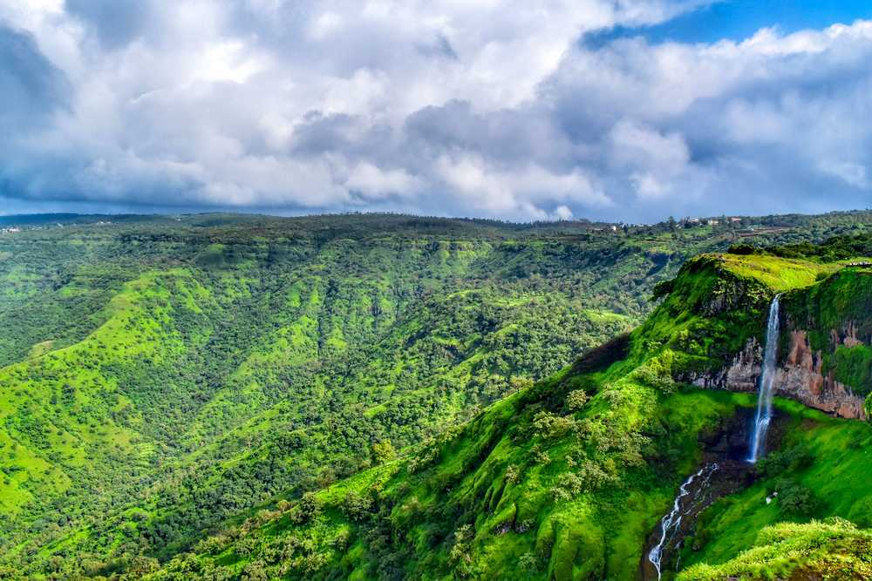

* **TRANSPORTATION-**

Flight-

The closest airport to Mahabaleshwar is located in Pune at the distance of about one hundred and twenty kilometres. This airport is very well linked to many other major domestic and international airports. An excellent taxi service is also available at the airport.

Road-

Frequently running buses connect Mahabaleshwar to other major towns and cities by means of roadways. One can take a tourist bus from Mumbai, which runs from Sion, Vashi and Dadar (East). It takes around 6 hours to reach Mahabaleshwar from Mumbai. If travelling from Pune, currently the tourist buses are operated mainly by two private companies. Alternatively, if travelling by a private vehicle, it takes around 4 to 5 hours from Mumbai through the Panvel-Mahad-Poladpur way. This is the preferred option to drive down from Mumbai. .

Train-

The closest railway station to Mahabaleshwar is situated in Wathar which is at the distance of sixty kilometres from Mahabaleshwar. This railway station then links to the other railway stations. Alternatively, one can reach Satara by a train from Mumbai/Pune and hire a taxi to Mahabaleshwar, which takes around an hour.

Local transport-

You can book govt tourist buses, or hire a cab which are pretty inexpensive. For the adventurous, there is also the option of horse rides to see the places.

1. ***Shirdi***-

**Shirdi** is a town in the state of Maharashtra, in western India. It's known as the former home of revered spiritual leader Sai Baba, and as a major pilgrimage site. Devotees gather daily at the Sai Baba Temple complex to honor his legacy. Here, the Samadhi Mandir shrine has an ornate marble statue of Sai Baba, alongside his tomb. Close by are Dwarkamai, a mosque where Sai Baba once lived, and tree-lined Lendi Garden.

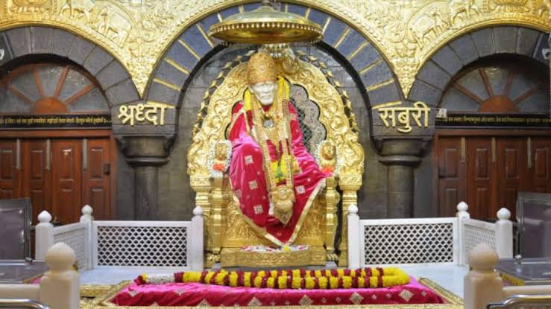

* **TRANSPORTATION-**

Flight-

The Aurangabad airport is the closest airport to Shirdi. After arriving at Aurangabad, you could get a bus that drops you at Shirdi.

Road-

Interstate and intrastate bus services are regularly available that can take you to Shirdi.

Train-

Nearest railway station to Shirdi is Sainagar Shirdi Railway Station. It is very well connected to most major cities in the country.

Local transport-

Tourist cabs, taxis and buses are the main mode of transportation. Bus is the best way to travel within the town. One can also take permission from Shri Sai Sansthan Temple in order to land their helicopter on the helipad managed by them. The main temple is just 10 minutes walk from the helipad. By foot is another recommended way to travel within the city as Shirdi being a small town, all the temples are located close by.

1. ***Mumbai-***-

**Mumbai** (formerly called Bombay) is a densely populated city on India’s west coast. A financial center, it's India's largest city. On the Mumbai Harbour waterfront stands the iconic Gateway of India stone arch, built by the British Raj in 1924. Offshore, nearby Elephanta Island holds ancient cave temples dedicated to the Hindu god Shiva. The city's also famous as the heart of the Bollywood film industry.

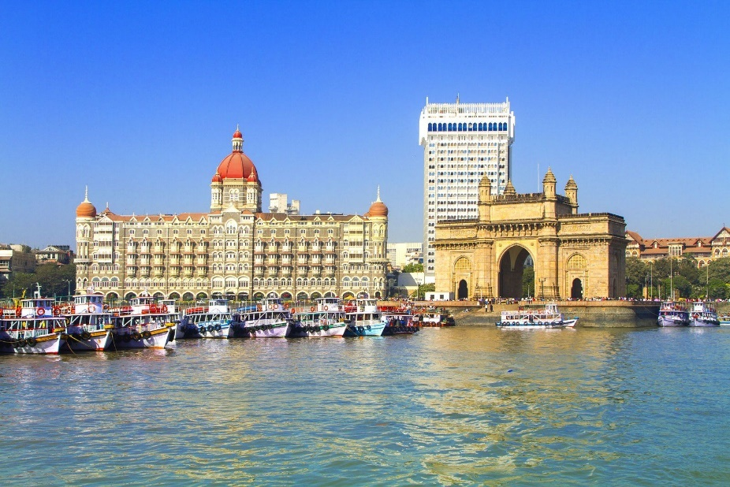

* **TRANSPORTATION-**

Flight-

Mumbai has excellent connectivity with most of the major cities around the world, as well as the domestic sectors, making it the second busiest aviation hub in India. The Chhatrapati Shivaji International Airport is the country main international gateway and many international airlines operate from here. The airport has two terminals - Terminal 1A serving Air India, and Terminal 1B serving other airlines such as IndiGo, Jet Airways, SpiceJet and GO Air. The airport is 28 km from downtown Mumbai and you can take a prepaid taxi available there. Buses are also available that takes you to the Andheri Station.

Road-

Mumbai has road links to all parts of the country with the Mumbai-Pune Expressway being the most popular of the lot. The road conditions are better than the rest of the country. Mumbai is also well served by buses from all the major destinations. The Asiad Bus Service is a bus terminal located on the Dadar road from where buses travel to Pune regularly. The Maharashtra State Road Transport Corporation operate services in Mumbai from various cities in Maharashtra.

Train-

The nearest railway station is Chhatrapati Shivaji Terminus Railway Station, also the second largest railway station in the world. 12.3 km away from the Mumbai city, via Western Highway, this station is well connected to the rest of India. There are many more stations, viz. Mumbai Central and Lokmanya Tilak Terminal that serve the city of Mumbai. Alternatively, when in Mumbai, the local train service is arguably the most affordable option for an intra-Mumbai visit.

Waterways-

Though the Mumbai cruise industry is still developing, there are numerous travel organisations that offer cruises to and from Singapore, Malaysia, Dubai, etc. Ferries are available from Ferry Wharf to access islands and beaches in the vicinity of the city and the Elephanta Caves.

Local transport-

Public transport is very accessible, as well as affordable in Mumbai. Unlike most other parts of India, the auto rickshaws travel by meter and don't fuss about the destination. The base fare is Rs. 18 for the first 1.5 km, and then Rs. 12. 19 per km. Mumbai also has a good and extensive bus network, The BEST bus network, which runs AC buses as well. The local black and yellow or the kaali-peeli taxis are also a popular mode of commuting in the city as they run on reasonable rates and are readily available. However, the traffic conditions in Mumbai are terrible, making local trains the best option to reach somewhere on time.

1. ***Lonavala***-

**Lonavala** is a hill station surrounded by green valleys in western India near Mumbai. The Karla Caves and the Bhaja Caves are ancient Buddhist shrines carved out of the rock. They feature massive pillars and intricate relief sculptures. South of the Bhaja Caves sits the imposing Lohagad Fort, with its 4 gates. West of here is Bhushi Dam, where water overflows onto a set of steps during rainy season.

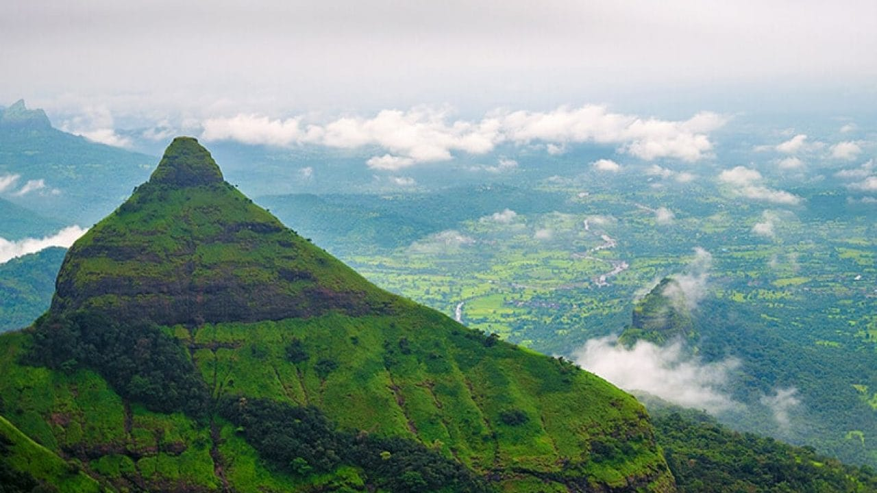

* **TRANSPORTATION-**

Flight-

Lonavala enjoys the proximity to two international airports- the Lohegaon Airport, Pune (70 km away) and Chhatrapati Shivaji International Airport, Mumbai (90 km away).

Road-

Situated on the Mumbai-Pune Expressway, Lonavala is well connected by a network of highways linking the two cities. A lot of the tourists visiting Lonavala prefer to drive down from Mumbai or Pune and enjoy the mesmerising ride.

Train-

The Lonavala Railway Station is an important junction of the Mumbai-Pune railway route and falls almost midway. Thus, all trains travelling from Mumbai to Pune and vice-versa stop at Lonavala. It takes around 2.5 hours by train from Mumbai and 1.5 hours by train from Pune to reach Lonavala.   
  
There are also direct trains running from Mumbai to Lonavala the most popular of which are Pragati Express (12125), Indrayani Exp (22105), Chennai Mail (11027), Deccan Queen (12123), and Bsl Pune Exp (11025).

Local transport-

Buses, autos and rented bicycles are available here if you do not have a private vehicle to your name. Auto's and taxis do not run on meter so it is advisable to fix the rate beforehand. Bus therefore is the best option to travel around the city.

1. **KARNATAKA**

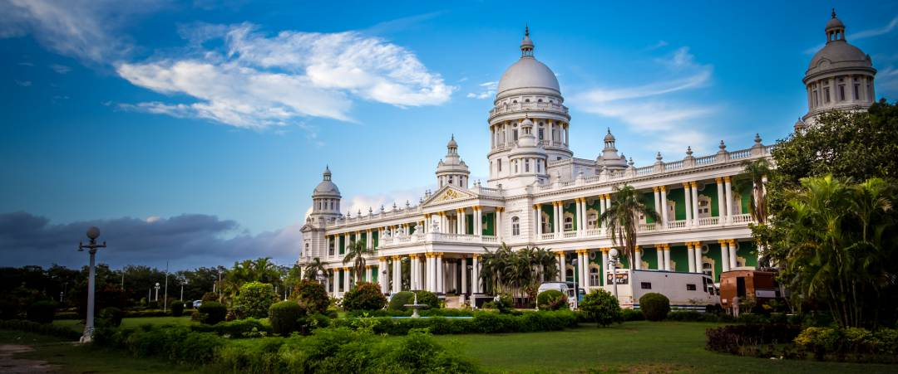

**Karnataka**, formerly [**Mysore State**](https://en.wikipedia.org/wiki/Mysore_State) is a [state](https://en.wikipedia.org/wiki/States_and_union_territories_of_India) in the southwestern region of [India](https://en.wikipedia.org/wiki/India). It was [formed](https://en.wikipedia.org/wiki/Unification_of_Karnataka) as Mysore State on 1 November 1956, with the passage of the [States Reorganisation Act](https://en.wikipedia.org/wiki/States_Reorganisation_Act,_1956) and renamed *Karnataka* in 1973. The state corresponds to the [Carnatic region](https://en.wikipedia.org/wiki/Carnatic_region). Its capital and largest city is [Bengaluru](https://en.wikipedia.org/wiki/Bangalore).

Karnataka is bordered by the [Lakshadweep Sea](https://en.wikipedia.org/wiki/Lakshadweep_Sea) to the west, [Goa](https://en.wikipedia.org/wiki/Goa) to the northwest, [Maharashtra](https://en.wikipedia.org/wiki/Maharashtra) to the north, [Telangana](https://en.wikipedia.org/wiki/Telangana) to the northeast, [Andhra Pradesh](https://en.wikipedia.org/wiki/Andhra_Pradesh) to the east, [Tamil Nadu](https://en.wikipedia.org/wiki/Tamil_Nadu) to the southeast, and [Kerala](https://en.wikipedia.org/wiki/Kerala) to the southwest. It is the only southern state to have land borders with all of the other four southern Indian sister states.

* **FAMOUS PLACES-**

1. ***Coorg***-

**Coorg**, officially known as Kodagu, is the most affluent hill station in Karnataka. It is well known for its breathtakingly exotic scenery and lush greenery. Forest covered hills, spice and coffee plantations only add to the landscape. [Madikeri](https://www.holidify.com/places/madikeri/) is the region's centre point with all transportation for getting around starting from here. On a visit to Coorg, cover the beautiful towns like Virajpet, Kushalnagar, Gonikoppal, Pollibetta, and Somwarpet, and experience the beautiful concept of "homestays" to make your experience more memorable.

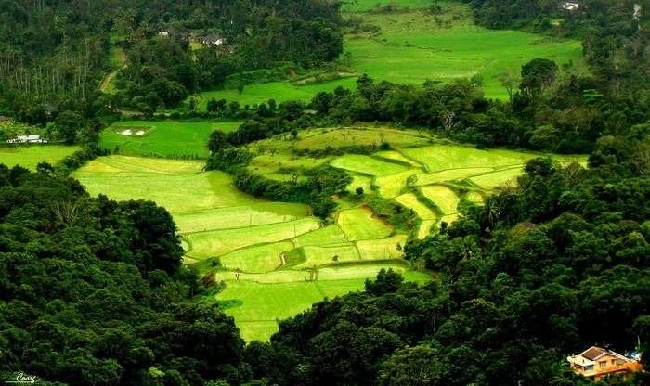

* **TRANSPORTATION-**

Flight-

The nearest airport to Coorg is the Mangalore International Airport, which lies at a distance of 165 km from Coorg. From here on you can take a cab to reach Coorg.

Road-

Coorg is well-connected by road from the main cities of South India. You can catch deluxe KSRTC buses to Coorg from Mangalore, Bengaluru and Mysore.

Train-

The nearest railway station to Coorg is at Mysore, 95 km away. You can hire a taxi from Mysore to reach Coorg. Alternatively, you can also hop on a bus which runs from outside the railway station to Coorg.

Local transport-

Public transport in Coorg is not very efficient, and it is preferable for tourists to hire rickshaws or cars. Cycling is also a common means of transportation for the sports enthusiasts.

1. ***Mysore***-

**Mysore** (or Mysuru), a city in India's southwestern Karnataka state, was the capital of the Kingdom of Mysore from 1399 to 1947. In its center is opulent Mysore Palace, seat of the former ruling Wodeyar dynasty. The palace blends Hindu, Islamic, Gothic and Rajput styles. Mysore is also home to the centuries-old Devaraja Market, filled with spices, silk and sandalwood.

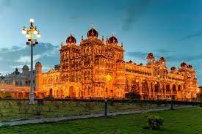

* **TRANSPORTATION-**

Flight-

The closest International Airport from Mysore is the Bangalore airport for those who want to visit the city by air across the border. There is a domestic airport within the city itself that schedules flights to and from the major cities like Chennai, Mumbai, Bangalore, New Delhi and Kolkata.

Road-

Mysore is 139 km toward the south-west of Bangalore. The state highway that connects these two cities is extremely well maintained. Heading out from Bangalore to Mysore by road is a wonderful experience and will take around 3hrs. The Karnataka Road Transport Corporation has brilliant transport administration to Mysore.

Train-

The Mysore Railway Station that is located in the heart of the city connects the city with every major city in India.  Mysore railway station has three lines that connect the city to Bangalore, Hassan and Chamarajanagar.

Local transport-

The best way to travel within the city is to hire an auto rickshaw. They are the most reliable and accessible way of commuting within the city as one can pay by meter during the day. However, after 10 pm, they charge 50% more than the meter reading, and after midnight you will have to pay twice the meter reading. One can also hire private taxis for the whole day from Car rental companies. Many hotels provide this service as well. Buses are also run by the State Government in and around Mysore. They run along fixed routes, and the cost is nominal. One popular mode of commuting among the tourists is the Tonga which is a horse carriage.

1. ***Hampi***-

**Hampi** is an ancient village in the south Indian state of Karnataka. It’s dotted with numerous ruined temple complexes from the Vijayanagara Empire. On the south bank of the River Tungabhadra is the 7th-century Hindu Virupaksha Temple, near the revived Hampi Bazaar. A carved stone chariot stands in front of the huge Vittala Temple site. Southeast of Hampi, Daroji Bear Sanctuary is home to the Indian sloth bear.

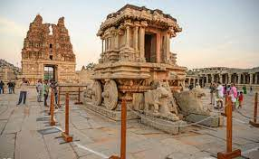

* **TRANSPORTATION-**

Flight-

The nearest airport to Hampi, Bellary is 60 km away from the temple town. Hubli Airport is another Airport which is 143 km away from Hampi. Also, JSW Vidyanagar Airport in Toranagallu is located approximately 40 kms from Hampi. However, if you are a foreigner visiting the places you need to step down at Bengaluru Airport to get Visa on Arrival. You can book domestic flight tickets from Bengaluru to Bellary or Hubli. Also, you could take a private taxi from Bengaluru Airport centre reach your final destination Hampi which is 350 km away from the International Airport..

Road-

There are buses to Hampi (or to Hospet) from major cities like Bangalore, Mumbai, Pune and Bellary. NH4 connects Bangalore to Hampi and it takes around 7 hours to reach here. From Hospet, it takes around 40 minutes by a local state-run bus to reach here..

Train-

Not having its own railways station, trains halt at Hospet Junction (13km). However, there are very few trains to Hosapete Junction (HPT) and they are mostly sold out well in advance during the season. It is actually quite easy to reach from Hospet to Hampi - there are state buses running from Hospet bus station to Hampi every 20-30 minutes (12 rs per person, Dec 2016). The last bus runs around 8 PM - be sure to confirm this time depending on the season from the bus stand. Otherwise, you can take a direct auto as well (200-300 per ride, Dec 2016) for Hampi from Hospet - they are easily available from the railway station/bus stand..

Local transport-

Taking a tour of empty winding parts is all you have to do. Rent a moped and make your way to the ruins and holy temples on it. You might catch locals giving bathe to elephants or playful monkeys trying to copy each other. The glimpses of the Boulder town as you ride through it will give a boom to your backpacker journey.

1. ***Badami***-

**Badami**, formerly known as Vātāpi is a town and headquarters of a taluk by the same name, in the Bagalkot district of Karnataka, India. It was the regal capital of the Badami Chalukyas from 540 to 757. It is famous for its rock cut monuments such as the **Badami** cave temples

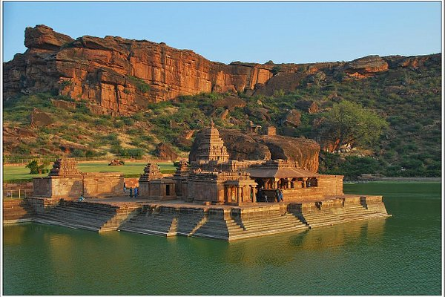

* **TRANSPORTATION-**

Flight-

The nearest major airport would be in Bangalore. From there, you could drive up to Badami.

Road-

Buses are available from most nearby cities and towns to Badami. However, the most convenient way to reach Badami is by road.

Train-

Badami can be reached via rail through the Badami Railway station. It is, however, only connected to nearby cities and towns like Bangalore and Belgaum.

Local transport-

Being a small town, autorickshaws or tongas are a preferable mode of transport within it. Cycles are also availbale for rent, but the best way to explore this town is by foot.

1. ***Bengaluru-***

**Bengaluru** (also called Bangalore) is the capital of India's southern Karnataka state. The center of India's high-tech industry, the city is also known for its parks and nightlife. By Cubbon Park, Vidhana Soudha is a Neo-Dravidian legislative building. Former royal residences include 19th-century Bangalore Palace, modeled after England’s Windsor Castle, and Tipu Sultan’s Summer Palace, an 18th-century teak structure

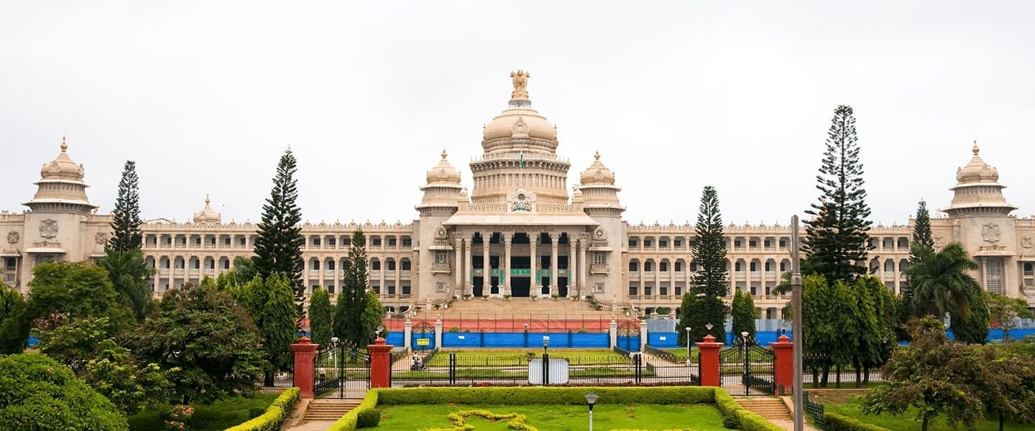

* **TRANSPORTATION-**

Flight-

Kempegowda International Airport is one of India's busiest and modern airports. It is connected to around 50 destinations across the country and plenty of international destinations as well. It hosts 10 domestic and 21 international airlines like Air India, Qatar, Emirates, Jet Airways, Etihad Airways, among many others.

Road-

If you are up for a little adventure, you can travel to Bangalore by bus. There are both government and private bus that operate from all the major towns like Mumbai, Goa, Chennai, Hyderabad, etc. The bus arrives and depart from the Bangalore Bus Stand which is located opposite to the Bangalore City railway station.

Train-

Bangalore has two main rail terminals- **The Bangalore City and Yeshwantpur Junction.** The Bangalore City is the major terminal situated in Majestic, which is the heart of the city and most trains arrive and depart from here.The Yeshwantpur Junction is located on NH-4 and mostly long-distance trains arrive and depart from here. After arriving at the junction, you will need to take a taxi or a rickshaw to the main city which is easily available outside the station.

Local transport-

The Bangalore Metropolitan Transport Corporation forms an important medium of transport in the city. It connects the whole town through various routes making travel simple. The ticket fares are around INR 15 for a distance of 7 km. There are also Volvo buses available throughout the city. From the airport, you can take a shuttle bus to reach different parts of the city. The Bangalore Airport Bus Service operates buses frequently throughout the day, and there are a few buses which run in the night as well.  
  
Ola cabs and Uber are available within minutes when booked through their app or through calls. Three-wheeled auto-rickshaws are a popular means of transport. But be wary of the auto fares here as the drivers tend to charge the highest fare possible and do not go by the fare meter. If the fares are too high, there are many app-based services like Ola and Uber that have autos as well.

**3.HIMACHAL PRADESH**

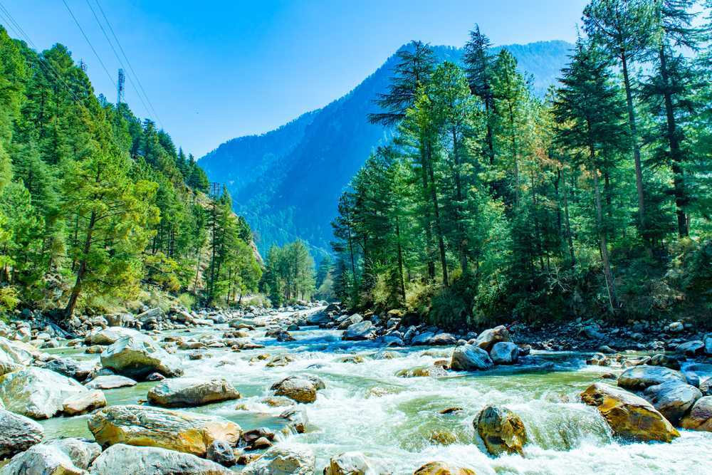

**Himachal Pradesh** is a northern Indian state in the Himalayas. It's home to scenic mountain towns and resorts such as Dalhousie. Host to the Dalai Lama, Himachal Pradesh has a strong Tibetan presence. This is reflected in its Buddhist temples and monasteries, as well as its vibrant Tibetan New Year celebrations. The region is also well known for its trekking, climbing and skiing areas

* **FAMOUS PLACES-**

1. ***Manali***-

**Manali** is a high-altitude Himalayan resort town in India’s northern Himachal Pradesh state. It has a reputation as a backpacking center and honeymoon destination. Set on the Beas River, it’s a gateway for skiing in the Solang Valley and trekking in Parvati Valley. It's also a jumping-off point for paragliding, rafting and mountaineering in the Pir Panjal mountains, home to 4,000m-high Rohtang Pass

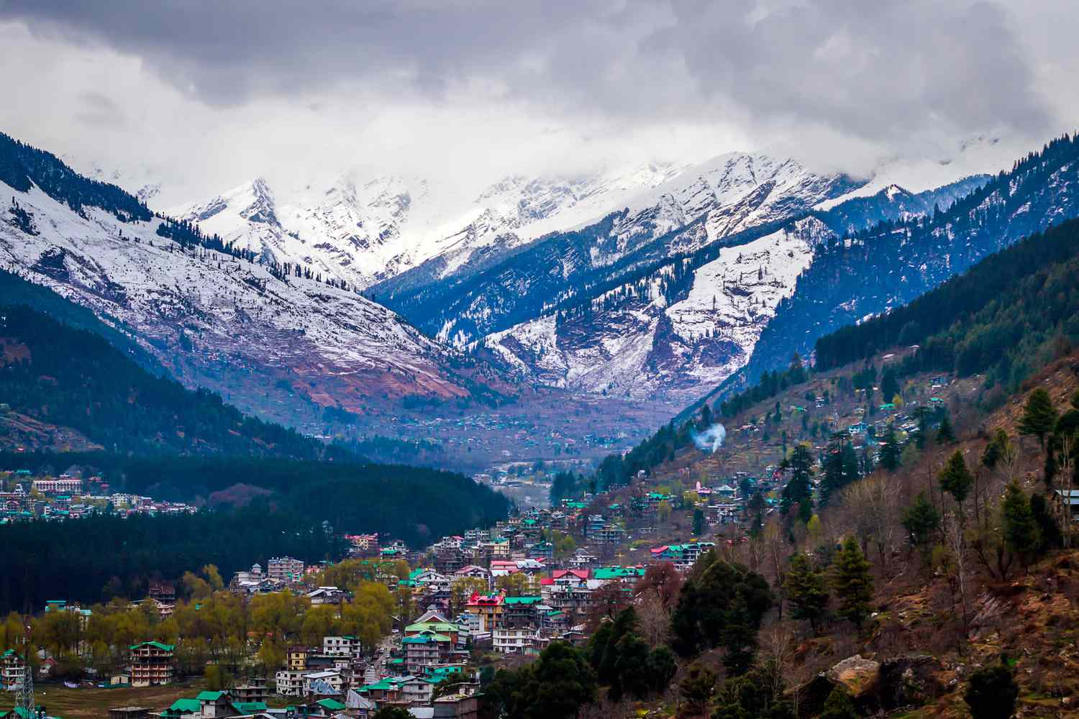

* **TRANSPORTATION-**

Flight-

The nearest airport is Bhuntar, located at a distance of 50km from Manali and 10km from Kullu. Air India operates a flight from Delhi to Kullu, however, services are irregular and prices very high. You can hire a taxi to go to Manali from the airport or you can go to Kullu and take a bus which operates frequently on this route.

Road-

There are frequent bus services from Delhi to Manali which is at a distance of 570 km. There are also bus services from Shimla, Dharamshala, Leh and Chandigarh. Alternatively, you can hire a taxi to travel to Manali. However, make sure the driver has experience driving in hilly regions.

Train-

The nearest railway station from Manali is in Joginder Nagar which is 50 km away. Ambala Cantt or Chandigarh are also feasible options.  It is well-served by rail but you will need to travel to Ambala to get a bus for Manali. However, this is a narrow-gauge railway station and hence is not connected to all the major cities in the country. The broad gauge railway stations nearest to Manali are in Chandigarh (310 km) and Ambala (300 km).

Local transport-

Taxis are easily available to cover the town. Walking is a therapeutic option.  
  
**Renting Bikes in Manali**  
  
Bikes are basically the 'go-anywhere do-anything machine' which serves the best option for travelling the roads of Manali. Setting on a thrilling journey. Bikes on Rent in Manali are the most commonly used bikes with options of 350 CC or 500 CC in Royal Enfield also known as Bullet. The cost of renting a bike/motorcycle is about INR 700 - INR 1500 per day per bike. The rental cost depends upon the model, duration (Bullet, Enfield, pulsar etc) and condition of the bike you choose. As for security deposit, you have to pay approximately INR 10,000 - INR 15,000 for non - local tours and INR 2,000 - INR 5,000 for local tours. You will need to submit identification documents too like passport, pan card, aadhar card etc along with the security deposit in many cases.

1. ***Kasol***-

**Kasol** is a hamlet in the Kullu district of the Indian state of Himachal Pradesh. It is situated in Parvati Valley, on the banks of the Parvati River, Between Bhuntar and Manikaran, it is located 30 km from Bhuntar and 36 km from Kullu town, the district headquarters, 3.5 km from Manikaran.

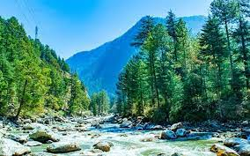

* **TRANSPORTATION-**

Flight-

Almost 31 Kms away, Bhuntar Airport located near Kullu is the nearest airport to the village. It is connected to three cities Delhi, Pathankot and Shimla. You can hire local cabs or private vehicles from there to reach Kasol.

Road-

The HRTC (Himachal Road Transport Corporation) runs regular buses from neighbouring states of Delhi, Haryana and Punjab. In the state itself they run to and fro from cities of pathankot, Shimla, Kangra, Solan and Dharamsala.

Train-

Pathankot serves as the nearest railhead at a distance of almost 150 Km,  
Himsagar Express, Andaman Express, Ten Jammu Express, and Sarvodaya Express are a few trains you can opt for. Chandigarh about 310 Km away is another option you can opt for. Taxis or private vehicles can be hired from here as well to reach Kasol.

Local transport-

Walking is the best way to commute in Kasol as the town is very small. However, if you wish to go to Manikaran or to Malana, then you might need to take a local taxi or a state bus to go there.

1. ***Shimla-***

**Shimla** is the capital of the northern Indian state of Himachal Pradesh, in the Himalayan foothills. Once the summer capital of British India, it remains the terminus of the narrow-gauge Kalka-Shimla Railway, completed in 1903. It’s also known for the handicraft shops that line The Mall, a pedestrian avenue, as well as the Lakkar Bazaar, a market specializing in wooden toys and crafts.

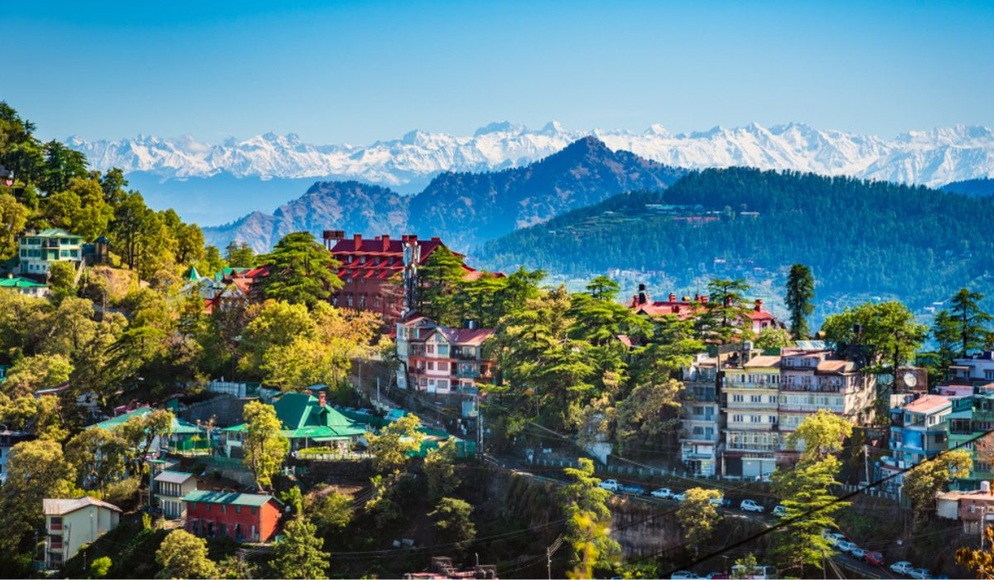

* **TRANSPORTATION-**

Flight-

The Shimla Airport, also known as Jubbarhatti airport is around 25 km away from the main city and is one of the very few airports at any of the hill stations. Probably one of the smallest airstrips, the ride is pretty bumpy in the plane when it lands. However, since this airport is not functional throughout the year, hence it's advisable to choose Chandigarh or Delhi as connecting airports. People coming by air till Chandigarh generally prefer to book cabs to reach Shimla, which will take 3-4 hours. There are regular buses too. From Delhi airport, it roughly takes around 7-8 hours to reach Shimla.

Road-

Shimla is a hot tourist destination and buses run for Shimla from as far as Delhi, Jaipur, Punjab, Haryana and parts of Uttar Pradesh. Taxis are widely available to travel to Shimla from Chandigarh and Delhi or from any other local places. Shimla is also very well connected with HRTC buses from almost all parts of Himachal Pradesh.

Train-

The nearest broad gauge railway station from Shimla is the Kalka Railway Station which is only 90 km away. It takes around 5-6 hours from Kalka to reach here by train, but it's a very beautiful journey with a lot of tunnels and scenery which makes up for the extra time taken on the route.

There are around 3-4 trains everyday from Kalka to Shimla. You can also travel by Rail car which is one of its kind in India).Chandigarh Railway station is also just 113 km away from Shimla.

From both of these railway stations, Shimla is well connected with local buses and cabs. Shimla has its own railway station, but only narrow gauge trains from Kalka arrive here.

Local transport-

Local bus service is easily available within Shimla from 7 AM to 9 PM. Buses mainly run on the Ring Road. There is a special bus reserved only for women. Himachal Pradesh Tourism also runs special buses for local sightseeing that cover only the tourist attractions.  
  
Private taxis are easily available and economically viable. Local sightseeing charges vary from 800 INR to 1500 INR per day. Auto rickshaws are not very popular in Himachal Pradesh.  
  
To travel to places like Mall, Ridge, Kali Bari, one has to walk to reach there are they are no vehicles zone. But you can avail the facility of elevator run by HP Tourism which links the lowest point of Shimla- Cart Road to the highest point - the Mall.

1. ***Spiti Valley-***

**Spiti** is a high-altitude region of the Himalayas, located in the north-eastern part of the northern Indian state of Himachal Pradesh. The name "Spiti" means "The middle land", i.e. the land between Tibet and India.

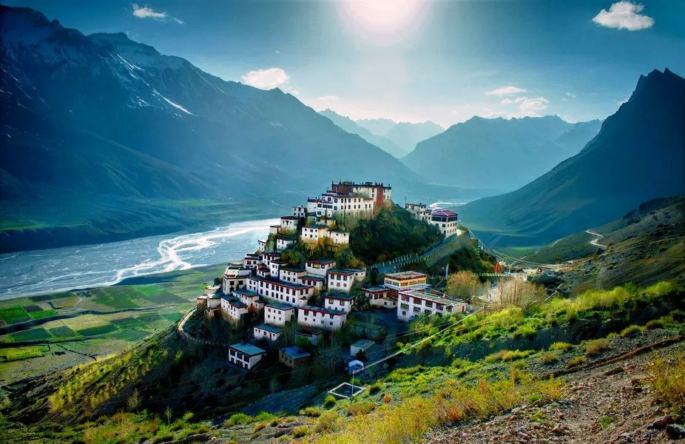

* **TRANSPORTATION-**

Flight-

There is no direct flight connectivity to Spiti Valley. The nearest airport is in Bhuntar, near Kullu, 245 km away from the same. However, Bhuntar airport is small with limited operations. Chandigarh Airport, located at a distance of 522 km is the nearest international airport.

Road-

Regular bus services ply to and fro the city of Spiti Valley. They operate on a daily basis, whether day or night, from places like New Delhi, Pathankot, Shimla etc. You can also take shared taxis or cabs for the same route.

Train-

The nearest broad gauge railway station from Spiti which have good connectivity is in Chandigarh. Jogindernagar also has a railway station which is nearest to Spiti, but it has very poor connectivity.

Local transport-

The term Spiti means 'The Middle Land', as Spiti Valley separates India from Tibet. Scantily populated, Spiti is an adventure lover’s paradise, with a number of trekking trails that tourists can choose from. All of these treks start from Kaza (Spiti’s capital from where you make your base camp) to various peaks from where you can get panoramic views of the Himalayan mountains. An easy 1.5-kilometre trek along the Spiti River from Dhankar Monastery to Dhankar Lake promises gorgeous views of the villages below. The Dhankar Lake itself is a place where you can sit back and relax amidst the cool mountain air.  
  
The mountain ropeway from Kibber to Chichum is also another popular tourist attraction that offers spectacular views of the gorge below, as well a bird’s eye view of the surrounding peaks.

1. ***Kasauli-***

**Kasauli** is a small hill town in the north Indian state of Himachal Pradesh. It’s home to gabled colonial-era houses, orchards and green-roofed Christ Church, dating from the mid-19th century. At the southern edge of town, Monkey Point overlooks forests of horse chestnut and Himalayan oak. A small temple also sits atop the hill. Nearby, the Gilbert Nature Trail winds through lush green countryside rich in birdlife.

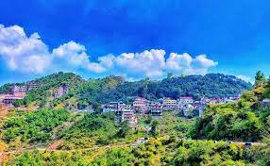

* **TRANSPORTATION-**

Flight-

The nearest airport Chandigarh is well connected to all major cities through a number of regular flights. Tourists can avail this mode of transport to reach Kasauli in the shortest time.

Road-

The Himachal Pradesh State Transport Corporation runs several buses between Kasauli and the other cities in the state and also nearby cities like Chandigarh. Though the bus journey is tedious, the beautiful scenery makes it an enjoyable ride.

Train-

The Indian Railways offer a number of express trains to reach Kalka from other parts of India including Mumbai, Chennai and Kolkata. You can easily available this route too. A train ride through the hills of Himachal is a rejuvenating experience in itself.

Local transport-

Taxis are easily available to go around the town.

1. **KERELA**

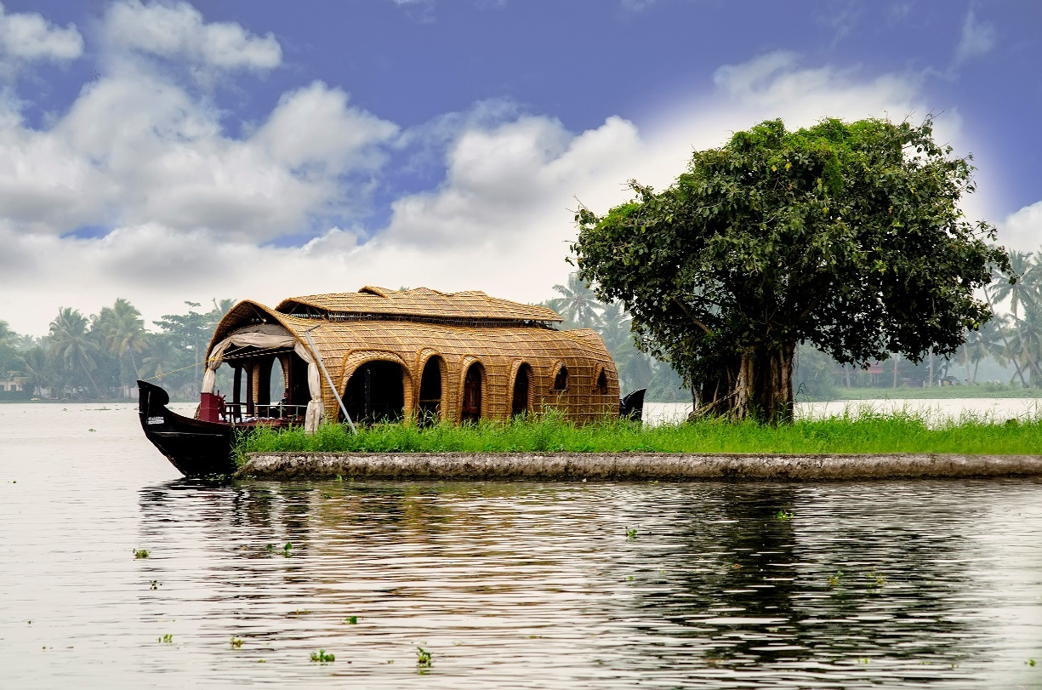

**Kerala**, a state on India's tropical Malabar Coast, has nearly 600km of Arabian Sea shoreline. It's known for its palm-lined beaches and backwaters, a network of canals. Inland are the Western Ghats, mountains whose slopes support tea, coffee and spice plantations as well as wildlife. National parks like Eravikulam and Periyar, plus Wayanad and other sanctuaries, are home to elephants, langur monkeys and tigers.

* **FAMOUS PLACES-**

1. ***Munnar***-

**Munnar** is a town in the Western Ghats mountain range in India’s Kerala state. A hill station and former resort for the British Raj elite, it's surrounded by rolling hills dotted with tea plantations established in the late 19th century. Eravikulam National Park, a habitat for the endangered mountain goat Nilgiri tahr, is home to the Lakkam Waterfalls, hiking trails and 2,695m-tall Anamudi Peak..

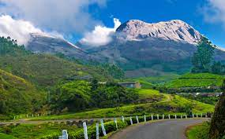

* **TRANSPORTATION-**

Flight-

Munnar does not have its own airport. If you wish to fly to Munnar, the nearest airport is Cochin International airport, which is located at a distance of 110 km from Munnar. From here on, you can hire a cab or board the Kerala road transport buses directly to Munnar.

Road-

Munnar is well-connected from the main cities of Kerala. You can find a huge number of public buses from all the major cities of Kerala. Buses are also available from Tamil Nadu to Munnar at a reasonable fare.

Train-

The nearest railway station to Munnar is Aluva, located approximately 100 km away from Munnar. To cover the rest of the journey you can either catch a bus or hire a private taxi.

Local transport-

**Bus**  
Local government buses are available with ticket priced between INR 5 - INR 25  
  
**Cab**  
Local cabs are easily available for hire. The fare is approximately INR 1000 to INR 1500 for 150 km.  
  
**Auto-rickshaws**  
Most of the autos have metres and they are a cheaper mode of transportation than taxis  
  
**Bike-rental**  
Bikes are easily available for rent at a tariff of INR 300 - INR 400 for one day.

1. ***Alleppey***-

**Alappuzha (or Alleppey)** is a city on the Laccadive Sea in the southern Indian state of Kerala. It's best known for houseboat cruises along the rustic Kerala backwaters, a network of tranquil canals and lagoons. Alappuzha Beach is the site of the 19th-century Alappuzha Lighthouse. The city's Mullakkal Temple features a traditional design. Punnamada Lake's snake boat races are a well-known annual event.

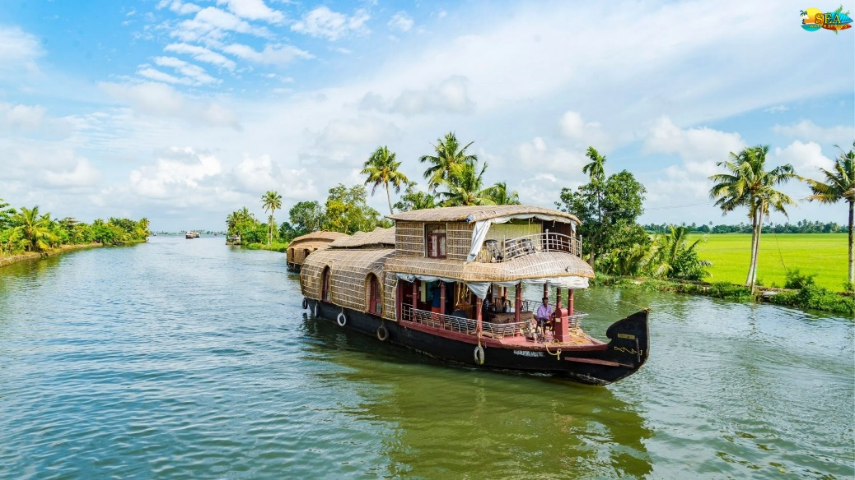

* **TRANSPORTATION-**

Flight-

There is no direct flight connectivity to Alleppey. The nearest airport is in Kochi, which is around 60 km. away from the city of Alleppey. You can take a taxi once you touch down at Kochi airport.

Road-

Alleppey is easily accessible through the NH 66 that passes through the city. The national highway connects to other major nearby cities like Coimbatore, Ernakulam, Thrissur, Kollam and Trivandrum. There are state-run KSRTC Buses and Private AC Buses that ply through the city 24/7.

Train-

Alappuzha railway station is the principal station that connects Alleppey to the rest of India via railways. There are numerous trains from Alleppey to other major cities.

Local transport-

Traveling within Alleppey is not a problem as there is an abundant number of local buses, auto rickshaws and taxis. Auto rickshaws from the railway station to boat jetty will cost around INR 70. Boats and ferry services are the best way to travel places such as Kuttanad, inaccessible by road. Many of Alleppey's attractions are easily accessible by foot.

1. ***Kochi***-

**Kochi (also known as Cochin)** is a city in southwest India's coastal Kerala state. It has been a port since 1341, when a flood carved out its harbor and opened it to Arab, Chinese and European merchants. Sites reflecting those influences include Fort Kochi, a settlement with tiled colonial bungalows and diverse houses of worship. Cantilevered Chinese fishing nets, typical of Kochi, have been in use for centuries.

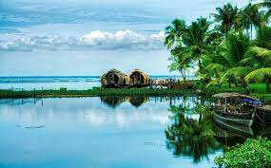

* **TRANSPORTATION-**

Flight-

Cochin International Airport connects Kochi to the rest of the world by air. The airport offers both domestic and international flights on a regular basis.

Road-

Regular bus services ply to and fro the city of Kochi. They operate on a daily basis, whether day or night. You can also take shared taxis or cabs for the same route.

Train-

Kochi is well connected to the rest of India by the railways. Regular rail services ply to and fro the city of Kochi. Three stations serve Kochi, among which the largest and perhaps the busiest one is the Ernakulam Junction South.

Local transport-

A number of buses, autos, taxis and boats ferry people around at all times of the day. Ola and Uber services are also available. The Cochin airport is at a distance of almost 36 km from Fort Kochi area, so one can also opt for buses run by KSRTC. The timetable can be found [here.](http://www.keralartc.com/html/JnNURMTimeEkm.html)

The Kochi Metro Line has finished construction and is fully operational. The total length of the Kochi Metro Line spans almost 26km and has a total number of 22 stops. The following is the list of **Metro Stations in Kochi:**

* Aluva
* Pulinchodu
* Ambattukavu
* Muttom
* Kalamassery Town
* Cochin University
* Pathadipalam
* Edapally
* Changampuzha Park
* Palarivattom
* JLN Stadium
* Kaloor
* Town Hall
* M.G Road
* Maharaja's College
* Ernakulam South
* Kadavanthra
* Elamkulam
* Vytilla
* Thaikoodam
* Petta

1. ***Periyar National Park, Thekkady***-

**Periyar National Park, also known as Periyar** **Tiger Reserve**, is in the mountainous Western Ghats of Kerala, southern India. This wildlife sanctuary is home to tigers and a significant elephant population, as well as rare lion-tailed macaques, sambar deer, leopards and Indian bison. In the park's north, Periyar Lake is popular for boat rides. Farther north, spice plantations surround the town of Kumily.

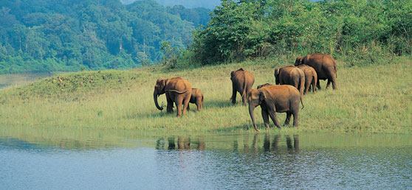

* **TRANSPORTATION-**

Flight-

The nearest airport from Thekkady is Madurai, which is connected to most major airports like Chennai and Coimbatore. The other nearest airport is the Nedumbassery Airport in Kochi. You can hire a taxi from Kochi Airport to reach Thekkady.

Road-

State Buses operate on a regular basis from the nearby cities like Kottayam, Kochi and Trivandrum. Alternatively, you can also book a cab from any of the nearby cities and travel to Thekkady.

Train-

The nearest railway station to Thekkady is in Kottayam, 114 km away. You can hire a taxi from the railway station to reach Thekkady.

Local transport-

Buses, Taxis and Autos can be found in abundance.

1. ***Kovalam***-

**Kovalam** is a small coastal town in the southern Indian state of Kerala, south of Thiruvananthapuram. At the southern end of Lighthouse Beach is a striped lighthouse with a viewing platform. Palm-backed beaches also include Hawa Beach and Samudra Beach. Heading south, Vizhinjam Juma Masjid mosque overlooks the busy fishing harbor. Inland, Sagarika Marine Research Aquarium displays technology used in pearl production.

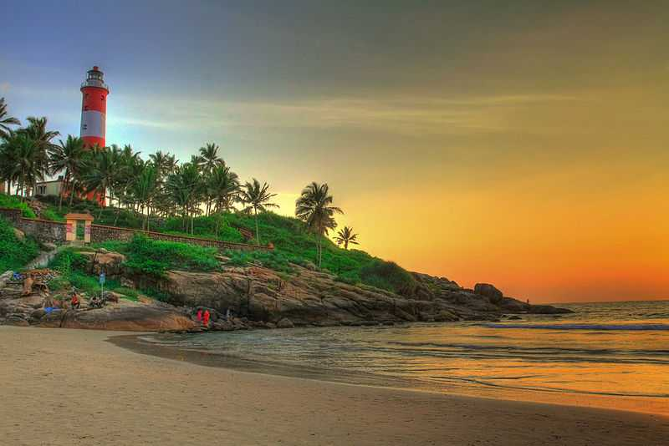

* **TRANSPORTATION-**

Flight-

Located at a distance of about 15 kilometres, the Trivandrum International Airport is the nearest airport to Kovalam. The airport is connected to all major airports in India and major cities around the world, like Singapore and Colombo. From the airport you can hire a taxis, or even take a bus or *auto-rickshaws* to take you to Kovalam.

Road-

Self drive is perhaps the most enjoyable and hassle free way to reach Kovalam. Driving to Kovalam gives tourists the opportunity to enjoy the natural beauty along the way. One can easily hire a taxi or a car from tour operators in the area..

Train-

The Trivandrum Central railway station, located about 15 kilometres from Kovalam, is the nearest railway station to Kovalam. The Trivandrum Central railway station is well linked to major cities in India. From the railway station, one can hire a taxi or a cab or board a bus to reach Kovalam

Local transport-

Buses are the most economical way to reach Kovalam. Kovalam is well-connected to Trivandrum and other nearby major cities by city bus services. Luxury tourist bus services to Trivandrum are available from many nearby cities like Bangalore, Chennai, Madurai and Nagercoil.

**5.RAJASTHAN**

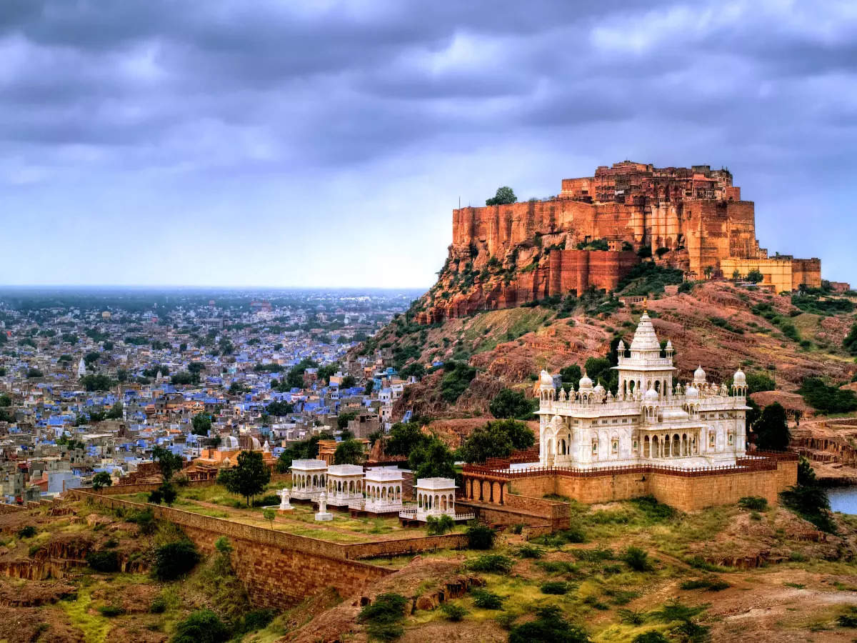

**Rajasthan** is the largest [state](https://hi.wikipedia.org/wiki/%E0%A4%B0%E0%A4%BE%E0%A4%9C%E0%A5%8D%E0%A4%AF) of the Republic of [India in terms of](https://hi.wikipedia.org/wiki/%E0%A4%AD%E0%A4%BE%E0%A4%B0%E0%A4%A4)[area](https://hi.wikipedia.org/wiki/%E0%A4%95%E0%A5%8D%E0%A4%B7%E0%A5%87%E0%A4%A4%E0%A5%8D%E0%A4%B0%E0%A4%AB%E0%A4%B2) . The state shares an international border of 1070 km with [Pakistan .](https://hi.wikipedia.org/wiki/%E0%A4%AA%E0%A4%BE%E0%A4%95%E0%A4%BF%E0%A4%B8%E0%A5%8D%E0%A4%A4%E0%A4%BE%E0%A4%A8)Which is known as Red Clip Line. Apart from this, it is also connected to the other five states of the country. It has [Gujarat](https://hi.wikipedia.org/wiki/%E0%A4%97%E0%A5%81%E0%A4%9C%E0%A4%B0%E0%A4%BE%E0%A4%A4)in the south-east , [Punjab (India) in the north, Uttar](https://hi.wikipedia.org/wiki/%E0%A4%AA%E0%A4%82%E0%A4%9C%E0%A4%BE%E0%A4%AC_(%E0%A4%AD%E0%A4%BE%E0%A4%B0%E0%A4%A4))[Pradesh](https://hi.wikipedia.org/wiki/%E0%A4%89%E0%A4%A4%E0%A5%8D%E0%A4%A4%E0%A4%B0%E0%A4%AA%E0%A5%8D%E0%A4%B0%E0%A4%A6%E0%A5%87%E0%A4%B6) and [Haryana](https://hi.wikipedia.org/wiki/%E0%A4%B9%E0%A4%B0%E0%A4%BF%E0%A4%AF%E0%A4%BE%E0%A4%A3%E0%A4%BE) in the north-east . The area of ​​the state is 3,42,239 km². According to the 2011 census, the literacy rate of Rajasthan is 70%.

[Jaipur](https://hi.wikipedia.org/wiki/%E0%A4%9C%E0%A4%AF%E0%A4%AA%E0%A5%81%E0%A4%B0)[is the capital](https://hi.wikipedia.org/wiki/%E0%A4%B0%E0%A4%BE%E0%A4%9C%E0%A4%A7%E0%A4%BE%E0%A4%A8%E0%A5%80) of the state and [Bikaner](https://hi.wikipedia.org/wiki/%E0%A4%AC%E0%A5%80%E0%A4%95%E0%A4%BE%E0%A4%A8%E0%A5%87%E0%A4%B0) is the sub-capital. Geographical features include [the Thar](https://hi.wikipedia.org/wiki/%E0%A4%A5%E0%A4%BE%E0%A4%B0) Desert in the west and the tail end of [the Ghaggar River.](https://hi.wikipedia.org/wiki/%E0%A4%98%E0%A4%97%E0%A5%8D%E0%A4%97%E0%A4%B0)Aravalli range is the only mountain range of Rajasthan, which is the center of tourism, includes [Mount Abu](https://hi.wikipedia.org/wiki/%E0%A4%AE%E0%A4%BE%E0%A4%89%E0%A4%82%E0%A4%9F_%E0%A4%86%E0%A4%AC%E0%A5%82) and the world famous [Dilwara temple in the ancient ranges of the world.](https://hi.wikipedia.org/wiki/%E0%A4%A6%E0%A5%87%E0%A4%B2%E0%A4%B5%E0%A4%BE%E0%A4%A1%E0%A4%BC%E0%A4%BE_%E0%A4%AE%E0%A4%82%E0%A4%A6%E0%A4%BF%E0%A4%B0)Rajasthan has three tiger reserves, Mukandra Hills.

* **FAMOUS PLACES-**

1. ***Jaipur***-

**Jaipur** is the capital of India’s Rajasthan state. It evokes the royal family that once ruled the region and that, in 1727, founded what is now called the Old City, or “Pink City” for its trademark building color. At the center of its stately street grid (notable in India) stands the opulent, colonnaded City Palace complex. With gardens, courtyards and museums, part of it is still a royal residence.

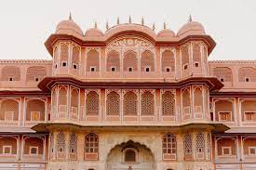

* **TRANSPORTATION-**

Flight-

Air travel is the most convenient way to reach the pink city. The Sanganer airport is well connected to the major cities of India as well as the globe through a number of airlines operating on a regular basis. Flights to international cities like Kuala Lumpur, Sharjah and Dubai are also easily available. Buses, taxis and cabs are easily available from the airport to reach the main city.

Road-

The Rajasthan State Road Transport Corporation (RSRTC) runs luxury and deluxe buses between Jaipur and other cities within the state of Rajasthan. There is a regular service from cities like New Delhi, Kota, Mumbai, Ahmedabad, Udaipur, Vadodara, and Ajmer at reasonable fares.

Train-

The Indian Railways offers a number of express trains to reach Jaipur from other parts of India.Trains like the Shatabdi Express connects Jaipur to almost all major cities of India. An additional attraction is "The Palace on Wheels" which offers a royal ride to Jaipur. A train journey through the desert is an enthralling experience in itself.

Local transport-

Autos are the most viable mode of transport except for when it gets too hot. Cabs also are very easily available. The city bus, a new addition for the tourists is a hop-on-hop-off service which is quite efficient. Though normal bus service is also available, we wouldn't recommend it for the tourists. Also, the Jaipur metro has made commuting efficient than ever.

1. ***Udaipur***-

**Udaipur**, formerly the capital of the Mewar Kingdom, is a city in the western Indian state of Rajasthan. Founded by Maharana Udai Singh II in 1559, it’s set around a series of artificial lakes and is known for its lavish royal residences. City Palace, overlooking Lake Pichola, is a monumental complex of 11 palaces, courtyards and gardens, famed for its intricate peacock mosaics.

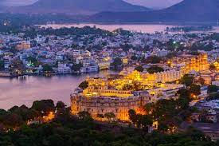

* **TRANSPORTATION-**

Flight-

The Maharana Pratap airport, also known as the Dabok airport is situated at a distance of 24km from Udaipur. Cities like Delhi, Mumbai and Jaipur have flights scheduled every day from here, which makes the travel quite convenient.

Road-

The city lies midway between Delhi and Mumbai, at the intersection of NH 8, Golden quadrilateral, East west Corridor and NH 76. Road travellers can drive down to the city either from Ahmedabad through NH8 which takes approximately 5 hours or from Jaipur which is a 6-hour journey via the Golden quadrilateral. It's also a 4-hour drive from Kota through the EW corridor.

Train-

There are two railway stations in Udaipur- Udaipur City railway station and Rana Pratap Nagar railway station, both well networked to most of the cities in India like Kolkata, Bangalore, New Delhi, Mumbai, Jaipur, Ajmer, Kota, Agra, etc. Both the stations are located within a distance of 3km from the city centre.

Local transport-

Hiring a cab for a day is a good idea. Travelling via three wheelers is an easy option and relatively cheaper too.

1. ***Jailsalmer***-

**Jaisalmer** is a former medieval trading center and a princely state in the western Indian state of Rajasthan, in the heart of the Thar Desert. Known as the "Golden City," it's distinguished by its yellow sandstone architecture. Dominating the skyline is Jaisalmer Fort, a sprawling hilltop citadel buttressed by 99 bastions. Behind its massive walls stand the ornate Maharaja's Palace and intricately carved Jain temples.

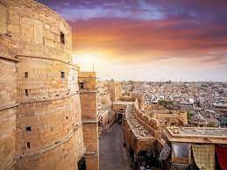

* **TRANSPORTATION-**

Flight-

There are regular flights from Delhi, Mumbai, and Bangalore to Jodhpur. One can take connecting flights to this place from the other cities. It is advisable to take a cab from the Jodhpur airport to Jaisalmer. The picturesque view will make the 4-5 hours journey worthwhile.

Road-

Jaisalmer is well connected via a network of roads to most nearby cities. Buses are also easily available since it is such a popular destination among tourist.

Train-

Jaisalmer is really well connected in terms of the railway network. Especially with cities like Delhi, Jaipur and Jodhpur, with major trains like “Delhi Jaisalmer Express”, “Jodhpur Jaisalmer Express”, and “Howrah Jaisalmer Express”. Rickshaws and autos are easily available outside the railway station. It usually takes about INR 40-50 for an auto ride to the centre of the city from the railway station.

Local transport-

Autos and tongas are the most widely used mode of transport within the city. Bargaining is the key to tackle the auto-rickshaw drivers. Autos only ply between 8 AM to 8 PM to go inside the fort area.  
  
Rickshaw pullers might not be as friendly as you would expect them to be, but it's the best way to beat the bottlenecks in the city. Bikes are available for rent too.  
  
Bicycles, however, are much more recommended as they can be manoeuvred easily in congested areas (the fares of the bicycle being borrowed varies according to the model one borrows).  
  
Hiring cabs for the entire day can be an expensive affair. But if you are willing to make this investment, a cab for four people can cost around INR 3000 for the entire day. If you are looking forward to booking a bike, the starting price is usually INR 1000 per day.

1. ***Jodhpur***-

**Jodhpur** is a city in the Thar Desert of the northwest Indian state of Rajasthan. Its 15th-century Mehrangarh Fort is a former palace that’s now a museum, displaying weapons, paintings and elaborate royal palanquins (sedan chairs). Set on on a rocky outcrop, the fort overlooks the walled city, where many buildings are painted the city’s iconic shade of blue.

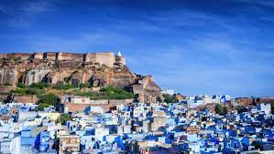

* **TRANSPORTATION-**

Flight-

Jodhpur has a well-functioning airport with direct flights to Mumbai/Delhi/Ahmedabad and some other cities in Gujarat/Rajasthan. Flights could be a little expensive as there are just a few flights to here, but if you book in advance you should be able to get a good price.

Road-

Jodhpur has great road connectivity from other parts of the state. You can book sleeper bus tickets from Delhi or Ahmedabad - these typically have an overnight schedule and drop you in Jodhpur early morning. They are quite cheap and comfortable, and a good way to reach Jodhpur if you're not able to get train tickets but want to do a budget trip.

Train-

Jodhpur railway station has good train connectivity with almost all the major cities in Rajasthan, and from Delhi/Mumbai/Ahmedabad and even Kolkata. From Delhi, taking a train is a very convenient option since you can take an overnight train to reach Jodhpur early morning. It takes a little long (around 16-18 hours) to reach from Mumbai. Jodhpur is well connected to Jaipur/Udaipur by train, so if you are planning a whole Rajasthan trip, traveling by train within Rajasthan is a good and cheap option.

Local transport-

Being a tourist attraction, commuting within the city is not an issue. Both Olacabs and Uber are available in Jodhpur at very reasonable rates, so you can use the app to conveniently hop from one location to another. However, these cabs don't enter a part of city which has narrow alleys. So it is better to ask the driver before boarding!  
Local autos are available as well - you'll need to bargain with them a little but they generally don't charge exorbitant prices. You can also talk to the auto drivers to stay with you the whole day - that's another convenient option.

1. ***Ranthambore National Park***-

**Ranthambore National Park** is a [national park](https://en.wikipedia.org/wiki/National_park) in [Rajasthan](https://en.wikipedia.org/wiki/Rajasthan), [India](https://en.wikipedia.org/wiki/India), with an area of 1,334 km2 (515 sq mi). It is bounded to the north by the [Banas River](https://en.wikipedia.org/wiki/Banas_River) and to the south by the [Chambal River](https://en.wikipedia.org/wiki/Chambal_River). It is named after the historic [Ranthambore Fort](https://en.wikipedia.org/wiki/Ranthambore_Fort), which lies within the park.

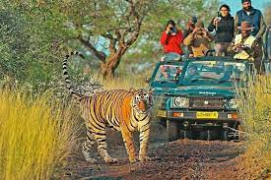

* **TRANSPORTATION-**

Flight-

The nearest airport is Jaipur International Airport, around 160 km away from Ranthambore, after which you can travel from Jaipur to Sawai Madhopur via rail/road.

Road-

Ranthambore is connected to the major cities via Sawai Madhopur. However, Kota-Ranthambore is a prominent highway; the distance can be easily covered in 1.5 hours. Jaipur is also just 160 km from Ranthambore and can be reached in about 3 hours.

Train-

The nearest railway station is Sawai Madhopur Railway Station which lies on the Delhi-Mumbai Trunk Route. Sawai Madhopur Railway station is just 11 km from the national park and hence acts as a very convenient way to reach Ranthambore.

Local transport-

Normally the resorts arrange for pick-up and drop to the railway station or to the reserve from where the safari starts. Local travel is by autos.